NETWORK THREATS AND MITIGATION

Q1. Create a table listing 5 common network threats (such as phishing, DDoS, man-in-the-middle, malware, and password attacks), and for each, write one real-world example from an app or service you use (like WhatsApp, Instagram, or Paytm).
Ans.
Network Threat | Real-World Example | Possible Impact
Phishing | A fake Instagram login message tricks users into entering their username and password on a fake website. | Account theft
DDoS Attack | An online service can be flooded with huge amounts of traffic, making it difficult for users to access it. | Service becomes unavailable
Man-in-the-Middle (MITM) | An attacker on an insecure public Wi-Fi network could try to intercept traffic between a user and WhatsApp Web. | Data or session exposure
Malware | A user downloads a malicious file pretending to be an Instagram utility or update. | Device or account compromise
Password Attack | An attacker repeatedly tries leaked or guessed passwords against a Paytm account. | Unauthorized account access

Note: These are realistic examples of how the threats could target users or services; they don't mean that the named companies were necessarily victims of the specific scenario described.
Q2. Simulate a brute-force attack scenario by writing a simple Python script that tries to guess a 4-digit PIN code by checking all possible combinations against a preset value. Constraint: The script should print the number of attempts it took to guess the correct PIN.
Ans. Here’s a simple educational Python simulation that checks every 4-digit combination against a preset PIN:
Output:
PIN guessed: 4726
Number of attempts: 4727
This demonstrates how a brute-force approach systematically checks possible combinations.

Q3. List 4 physical security risks that could affect a server room hosting a popular app like Zomato or BookMyShow, and suggest one mitigation step for each risk.
Ans.
Physical Security Risk | Mitigation
1. Unauthorized entry – Someone could enter the server room without permission. | Use access cards/biometric authentication and keep entry logs.
2. Fire – A fire could damage servers and networking equipment. | Install smoke/fire detection and automatic fire-suppression systems.
3. Power failure – Loss of electricity could shut down servers. | Use UPS systems and backup generators.
4. Water leakage/flooding – Water could damage electrical and server equipment. | Install water-leak sensors and keep equipment away from pipes or flood-prone areas.

Q4. Draw a simple floor plan (hand-drawn or digital) of a small office and mark at least 3 physical security measures you would implement to protect network equipment (such as CCTV, biometric access, or cable locks).
Ans.
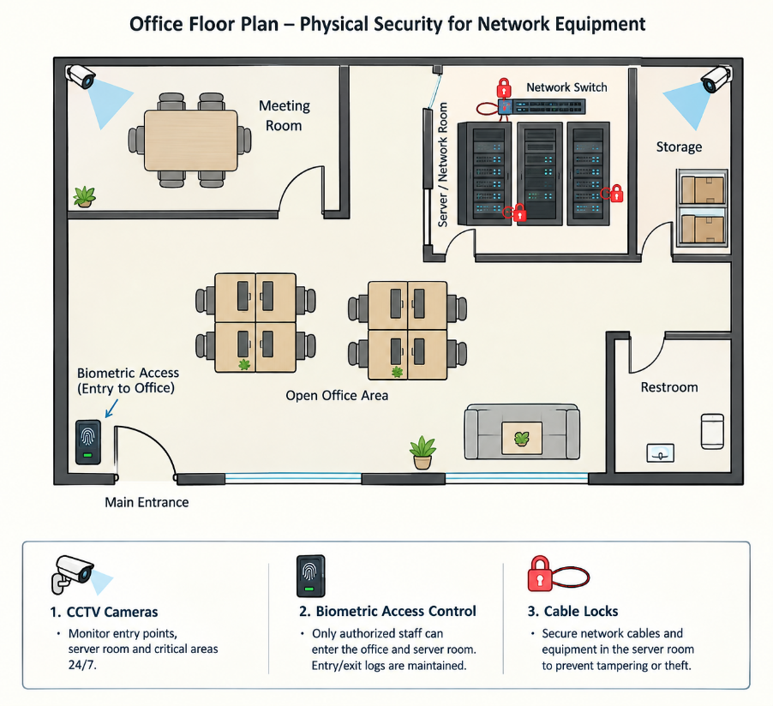
Q5. Use ChatGPT or a similar AI tool to generate a checklist of 7 actions a network admin should take to mitigate risks from both network threats and physical security breaches, then review and edit the checklist to make it specific for a college computer lab environment.
Ans.

NO | Action | College Lan- Specific Implementation
1 | Secure network access | Use strong Wi-Fi passwords and separate student, staff, and admin networks.
2 | Keep systems updated | Regularly update lab PCs, operating systems, browsers, and security software.
3 | Use firewalls and filtering | Block unnecessary ports and restrict access to unsafe or unauthorized websites/services.
4 | Protect user accounts | Require strong passwords and give students only the permissions they need.
5 | Control physical access | Lock networking equipment and server/rack areas; allow access only to authorized staff.
6 | Use CCTV and monitoring | Monitor lab entrances and network-equipment areas to deter theft or tampering.
7 | Back up important data | Maintain regular backups of lab configurations and important college data, preferably in a protected location.

Final review: The checklist covers both network threats (malware, unauthorized access, attacks) and physical threats (theft, tampering, and unauthorized entry) while being practical for a college computer lab.

